Assessment Examples

- Lesson #1: Example problem on worksheet for Pythagorean Theorem.
Help! There’s a dog stuck in the 3rd story of this burning building! Your ladder is 10m long and you place it 5m away from the building. How tall is the window to the 3rd story? (Leave answer with 2 decimals)
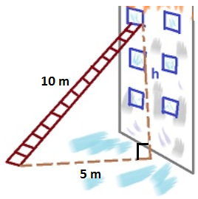 | Solution:  A=5m  B=???  C=10m  If A²+B²=C², then  (5)²+B²=(10)²  25 + B²=100  B²=75  B=√(75)= 8.66

- This is the worksheet that will be classwork during Lesson #2
http://www.mathworksheetsland.com/functions/1relations/ip.pdf
- Example questions from homework from Lesson #4

Graph f(x)=x² and graph h(x)=2x²+1.

How has the parent graph changed?
- The graph was inverted and shifted up 1
- The graph was shifted down 1 and doubled its x-values
- The graph was shifted up 1 and doubled its x-values
- None of the above
Draw the parent function of an exponential function and the parent function of a step function.

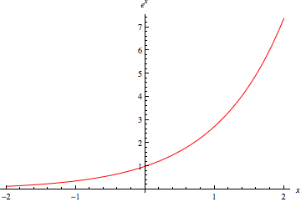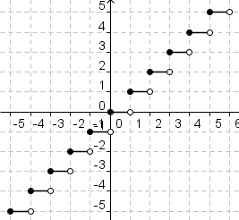

Exit Slip for Lesson Lesson #5
What is the definition of “composition”?

The way in which a whole or mixture is made up.

Give an example of a composition of two functions.

f(g(x)) f(x)=2x+5 g(x)=y²-7

If f(x)=6x²+7x and g(x)=.5x, what is g(f(x)) if x=4?

F(4)=6(4)²+7(4)=124 g(124)=.5(124)= 62

Pre-test & Post-test: I will be testing my students every day before the lesson begins. We will do a “bell work” of sorts that ask about what the next lesson will be on. The bell work will also include questions about the previous lesson. I will gauge the student’s progress by these bell works, and they will be collected every day to be graded.

